3E) MARGINAL COST BASED DECISION

Application of Marginal Costing in Managerial Decision Making : Marginal costing is very helpful in managerial decision making. Management's production and cost and sales decisions may be easily affected from marginal costing. That is the reason, it is the part of cost control method of costing accounting. Before explaining the application of marginal costing in managerial decision making, we are providing little introduction to this important concept.

Marginal cost is change in total cost due to increase or decrease of one unit or output. It is technique to show the effect on net profit if we classified total cost in variable cost and fixed cost. The ascertainment of marginal costs and of the effect on profit of changes in volume or type of output by differentiating between fixed costs and variable costs. In marginal costing, marginal cost is always equal to variable cost or cost of goods sold. We must know following formulae
a) Contribution (Per unit) = Sale per unit - Variable Cost per unit
b) Total profit or loss = Total Contribution - Total Fixed Costs
or, Contribution = Fixed Cost + Profit
or, Profit = Contribution - Fixed Cost
c) Profit Volume Ratio = Contribution/ Sale X 100 ( It means if we sell Rs. 100 product, what will be our contribution margin, more contribution margin means more profit)
d ) Break Even Point is a point where Total sale = Total Cost
e) Break Even Point (In unit) = Total Fixed expenses / Contribution
f) Break Even Point (In Sales Value) = Break even point (in units) X Selling price per unit
g) Break Even Point at earning of specific net profit margin
= Total Contribution / Contribution per unit
or = fixed cost + profit / selling price - variable cost per unit

Application of Marginal Costing in Managerial Decisions By effective use of marginal costing formulae, we can apply marginal costing for managerial decisions with following ways.

1st Application : Managerial Decision Relating to Determination of Optimum Selling Price.
To determine the optimum selling price of any product or service is big challenge for a manager of any company because company wants to profit of each unit of any product or service. In marginal costing technique, fixed cost will not be changed at any level of production. Only variable cost is changed for getting optimum selling price where company can achieve expected profit.

Break even units at desired profit = fixed cost + profit / selling price - variable cost per unit
or
No. of units expected to sell = Fixed cost + desired profit / contribution per unit
20000 = 180000 + 15% x ( 20000 x S.P) / selling price - 25
20000 x ( S.P. - 25) = 180000 + 15% x ( 20000 x S.P)
20000 S.P. - 500,000 = 180000 + 3000 S.P
20000 S.P - 3000 S.P = 180000 +500000
17000 S.P = 680000
S.P = 680000/17000 = 40 or, Expected Selling price = Rs. 40

2nd Application : To Check the Effect of Reducing of Current Price on profit.
We all know, this is the time of competition, customer has become king. He wants product at minimum price. One example, we can see free video on YouTube. Instead of buying costly CDs and DVD, customers of entertainment industry see free films and movies on YouTube. But on the other side, company wants to maintain his current profit. At that time, manager will be in tension because it is not possible to maintain profit even after reducing price. But if manager learns marginal costing techniques and uses it effective way, they can check the effect of reducing of current price on net profit, after this, he can decide to reduce production or increase production. It is the law of economics, variable cost will reduce by reducing units of production in same proportion but when we increase production, fixed cost will fastly decreases due to constant nature.

Example : Sale of a product amount to 1000 units per annum at Rs. 500 per unit. Fixed overheads are Rs. 100000 per annum and variable cost Rs. 300 per unit. There is a proposal to reduce the price by 20% due to survive in competition. How many units must be sold to maintain total profit after reducing the price by 20%?
First of all we check the effect of reducing of current price on profit.
Our Gross profit ratio or P/V Ratio without reducing price
= Gross profit or Contribution / Sale per unit x 100 = Sale per unit - variable cost per unit / sale per unit x 100
= 500 - 300/500 x 100 = 40%
Break Even Point ( in units where profit is zero ) = Fixed cost / Contribution per unit = 100000/ 200 = 500 units
After reducing 20% of sale price , our gross profit or P/V ratio will be
= 500 - 300 / 500 - 500 x 20% x 100 = 25%
It means our Gross profit will reduce 15% ( 40% - 25%) if we reduce our sale prices 20%.
Break Even Point ( in units where profit is zero ) = Fixed cost / Contribution per unit = 100000/ 100 = 1000 units
Now No. of Units Sold at Break Even point at desired profit :-
For this we have to know present profit
Present Gross profit or contribution = 40% gross margin on sale x ( total no. of sale units x sale per unit)
= 40% x ( 1000 units x Rs. 500 per unit ) = 2,00,000
Present Net Profit = Contribution or gross profit - Fixed cost
= 200,000 - 1,00,000 = 1,00,000
Now, number of units required to maintain same net profit
= Fixed cost + Net profit / New contribution after reduction of sale prices
= 1,00,000 + 1,00,000 / Rs. 100 = 200,000 / 100 = 2000 units
Now, manager has to take decision to produce more 1000 units if he wants to earn same gross margin 40% instead of 25%
3rd Application : Choosing Good Product Mix. It may be possible that company is producing more than one product, at that time company has to calculate each product's contribution margin or gross profit margin. After this, manager see which product is giving high contribution margin. Company manager will give preference to that product whose contribution will high. One more decision can be taken by manger. He can check contribution by producing different quantity of different products. If he see any quantity of products is producing maximum contribution, it will be equilibrium point. Production
of units at that quantity will be benefited to company.

4th Application : Calculation of Margin of Safety
Marginal costing can be utilized for calculating margin of safety. Margin of safety is difference between actual sale and sale at break even point. According to marginal costing rules, production will follow sales. Suppose current sale is Rs. 4,00,000 and BEP is Rs. 3,00,000, margin of safety is Rs.100000. We can calculate it with following formula
= Profit/ P/V ratio
If company's sale is less than margin of safety, then manager can take step to reduce both fixed and variable cost or increase prices.

5th Application : Decision Regarding Selling goods at Different Prices to Different Customers
Sometime, company has to give special discount to special customers. These customers may be govt, foreign companies or wholesaler. At that time manager has to take decision at what limit, we can give discount to special customers. Marginal costing may help in this decision.

Relationship between Average Variable Cost and Marginal Cost

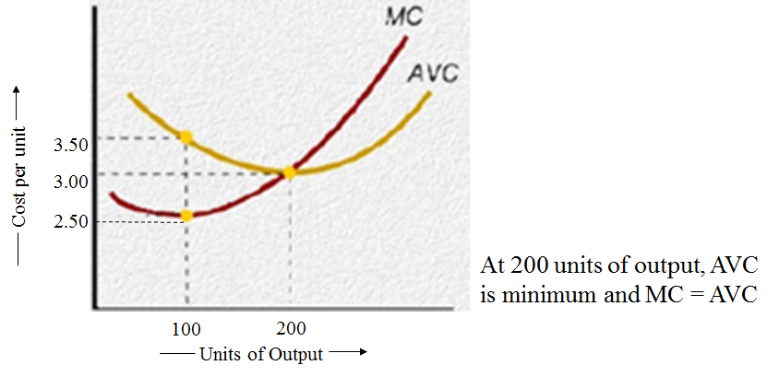
When Marginal Cost (MC) is below average cost, average cost is declining.
When Marginal Cost (MC) is above average cost, average cost is increasing.
Rising Marginal Cost (MC) intersects average variable cost at the minimum point of AVC.

